**SQL | Join (Inner, Left, Right and Full Joins)**

**A. INNER JOIN**

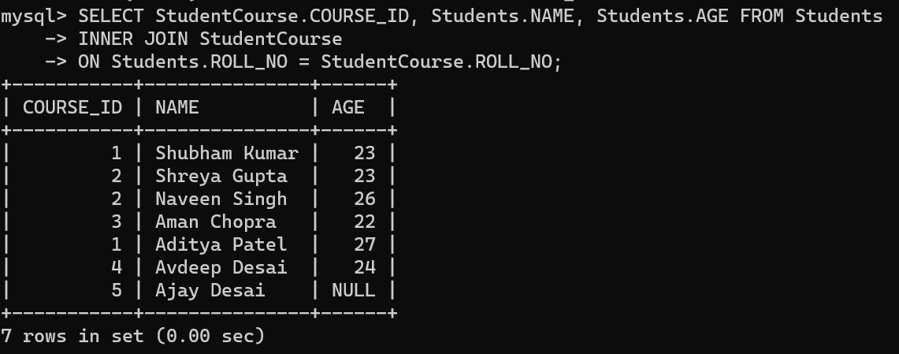

**B. LEFT JOIN**

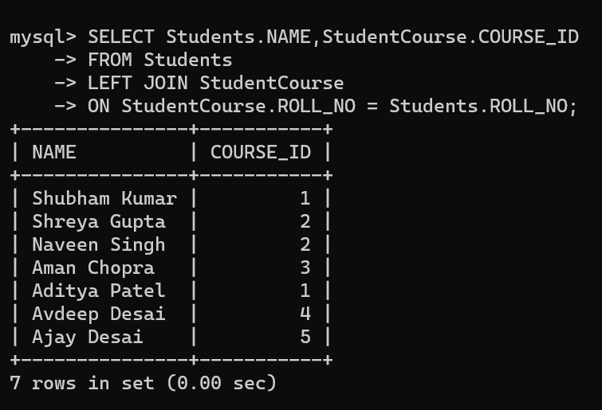

**C. RIGHT JOIN**

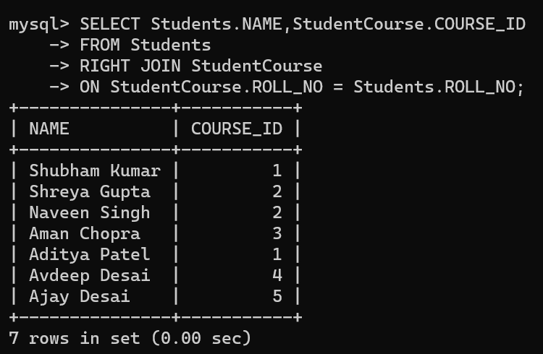

**D. FULL JOIN**